Sourcecode:

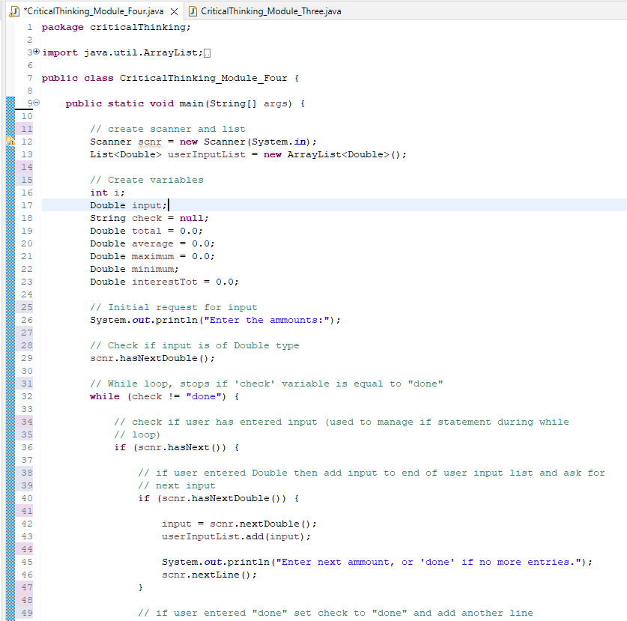

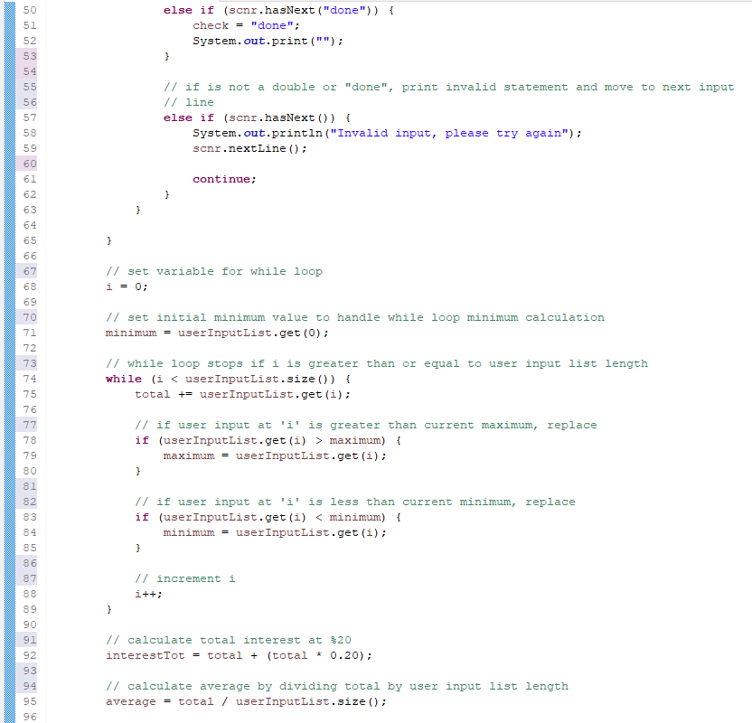

Running:

